**THE LIFE OF IVA MAE PORTER BROWNING**

**Chapter 1 – EARLY CHILDHOOD**

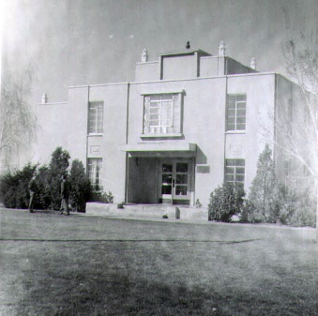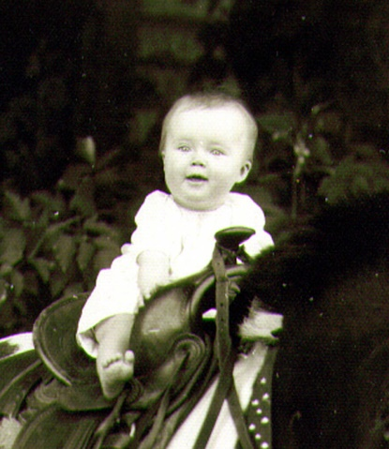 I was born on December 28, 1940 in the Dee Memorial Hospital in Ogden, Utah to wonderful parents, Glendon C and Mildred Hope Bushnell Porter. My parents, older brother, Hal, and I lived in Ogden until I was about a year and a half, then we moved to Sunset, Utah where my folks bought some property by the highway, and south of the Sunset church.

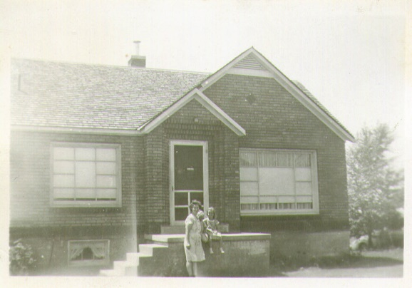 They first built a basement home, and later built on the upstairs. The basement home had a door which came in from the west. You came into the living room and then a large, narrow kitchen which had the small bathroom right in the same area as the kitchen. There was a small window above the sink which looked out at the highway. There were two bedrooms, one off the living room and one off the front of the kitchen. Then there was the furnace room and off from it was a long, very narrow fruit/vegetable area. It just had a cubby hole to get into it and there were spiders and cobwebs and I didn’t like to go there, but Mom asked me to go get a bottle of fruit, etc., at times and so I had to. We lived in that basement home from the time I was 1 ½ years old until I was about six. Dad had a contractor build our nice brick home on top of the basement home, and we thought it was so beautiful. Bryce was just a little guy, about two years old, when we moved upstairs. He was excited that he could stand by the windows in the front room and be able to look out and see the cars, trucks and buses go by as we were living by a main highway.

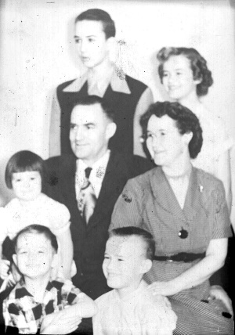 My brother, **Hal** is 18 months older than I, born on the 2nd of June 1939.  **Bryce** is about 4 years younger; he was born April 23, 1944. Mom was worried, after I was born, that Dad might have to fight in the 2nd World War so she put off having more children until this time. Dad was able to stay at the Arsenal and work on defense equipment there - much to their relief. On the 23rd of February 1948, **Terry** Glen was born. **Georgia** was born 2 ½ years later on the 8th of September so she is almost 11years younger than I, but boy was I ever excited when she was born as I had wanted a sister for many years. Georgia was named after Grandpa Bushnell as his name was George. They just took out the “e” and put “ia”, making it Georgia. Georgia and I shared the bedroom upstairs. At first Hal and I had bunkbeds, Hal slept on the top and I slept on the bottom on. We also had Bryce in a crib in that room. As Hal got older, he got a room downstairs and I shared the upstairs bedroom with Bryce and Terry. Bryce & I were on the bunkbeds and Terry in the crib. Later, the boys had bedrooms downstairs and Georgia & I shared the upstairs bedroom, we had a double bed at that time. While she was young, when I would go to school, she would get into my jewelry and other stuff and I didn’t like that. When we were older, and I was dating or babysitting, and I would come home and go to get in bed, Georgia would be on my side. I would roll her over and during the night, she would roll back and forth and swing her arms and legs over me, so she wasn’t a very good bed partner at that time. When I got married, Georgia was my pretty little flower girl. It was fun inviting my siblings to our home to stay for a night, weekend or longer after we were married. **Kim** Byron is the youngest, and is sixteen years younger, born on the 7th of September 1957. He was just a little guy when Ken and I got married.

I am very blessed to have been born to two such wonderful parents, who loved me and all their children 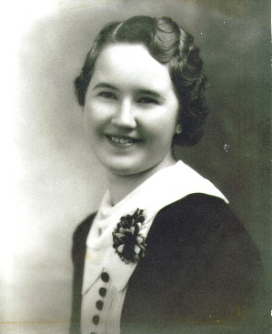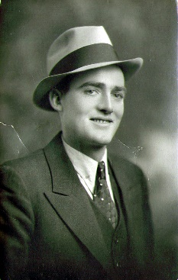and taught us the gospel both by word and by example. They were faithful, good honorable people. Mom was usually a very happy person and people loved to be around her. She had many friends and she was on the phone a lot because friends and family would call her as they loved to talk to her. She would cheer them up if they were discouraged or sad and if they had good news, they wanted to tell her. Mom didn’t gossip, but just loved to visit with people, they made her happy and she made them happy.

Dad was a hard-working, loving and kind father. He loved our mother, which was a great blessing. He loved the Lord and served Him the best of his ability and was very generous in his tithing, fast offerings and other church donations. Dad had a sense of humor, which I loved also. I loved to see and hear him laugh. He would call us kids silly names instead of our given names at times, and when we would say “DAD!”, he would laugh and laugh. Dad didn’t enjoy playing games like Mom did, but he did like playing “Authors”. He could look us each in the eye and say something like “Do you have Tom Sawyer by Mark Twain?” The way dad would look at you and the way he would say it, made you give yourself away and then we would have to give the card to him and he would laugh. In my mind, I can still see him doing that. He also played Panjandrum with us and after us kids were all married and moved out, he and mom would play it before going to bed many nights. I will tell more about Mom & Dad later.

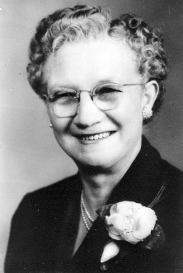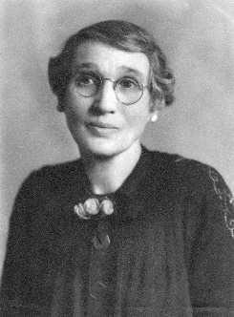I was named after my two grandmothers, Iva for my Grandmother Bushnell. and Mae for my Grandmother Porter. Her real name was Mary Elizabeth, but she went by "May", since she was named after her mother, Mary Elizabeth Clark Robinson. I feel very grateful to be named after these two special grandmothers who were loving, righteous women and who endured to the end despite many trials and challenges in their lives.

I have just a few experiences I would like to insert here of my years as a young child. These were impressed on my mind so much that I remember them after all these years

**“Lost in Salt Lake City”** When I was only two or three years old, I was Christmas shopping with my parents and older brother, Hal in Salt Lake City. It was snowing and I had on my new little red coat and bonnet. I became so involved in looking in the windows at all the neat toys, that the next thing I knew I couldn't find my family. I started crying and a nice lady took my hand and led me into the nearest store and explained to the manager that I was lost. The manager told her they would keep me there until my parents came after me. He then sat me up on the counter and gave me a lollipop and also a windmill to play with. I was enjoying myself when my father came in looking very worried and asked if they had seen a little girl in a red coat and bonnet. The clerk pointed over at me, and my daddy got a big smile on his face, came and grabbed me up and hugged me tight. I remember this experience, plus I heard the story when I was older, and they also told me of how worried they were. They had looked up and down the streets calling my name and asking people if they had seen me. Finally, Mom & Dad split up each looking in a different direction and agreed to meet in front of the information building on temple square. Dad said they had looked and looked and finally he went there to see if Mom had found me. He said as he approached her, and they both saw that neither of them had me, Mom began to cry and said her and Hal had been praying that Dad would have found me. Dad said he would go back and ask in the stores. They all prayed. We all thanked Heavenly Father afterwards, that I was found and that I was safe. My dad wrote me a letter while we were living in Arizona, one of the few letters I received from him, but it meant a lot to me. He told of this experience and I will quote from his letter...(I can’t find it)......................but I do remember what he told me. He said he went into the store named Kreses and asked one of the clerks if they had seen a little girl in a red coat and bonnet. The man smiled and said “yes, she is right over here.” Dad said he was so relieved, he picked me up and kept hugging me while he was crying. When mom & Hal saw dad coming down the sidewalk carrying me, they were so happy and relieved.

**I had terrible ear aches** from the time I was tiny until I had my tonsils out when I was about 4 or 5 years old. I remember waking up many times at night and my sweet Mom warming some ear drops or oil in a teaspoon on the stove, dropping it in my ear then putting cotton in and cuddling me up on her lap in the rocking chair. She would rock me while singing many songs until I fell back to sleep. The ones I remember most were "This Little Piggy Went To Market" and "Rock-a-bye and don't you cry and we will go to Grannies". I sang these to my little ones and now I do so to my grandchildren.

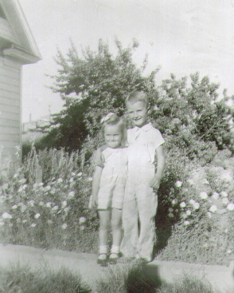

I remember when I got **my tonsils out**; it was done on our kitchen table while we were living in our basement home. Doctor Tanner used to make “home calls” back then. I think I was about 4 or 5 years old. Just before the doctor was to give me the ether, I remember Hal coming in and saying "Ha, Ha, we're going to have cake and ice cream and you can't have any". He was always a tease while we were growing up. He remarked after we were both married that he didn't know how I had survived our childhood as he was so mean to me. He said he was bored and didn't have anything better to do than tease and torment me, and he did plenty of that. Thank goodness we grew up and became good friends, when we reached our later teens and started dating.

Mom sang many songs as she worked around the house, cleaning, fixing meals, etc. Some were funny - "When I was born my Ma and Pa", "Two Little Girlies", "Slide down My Rain barrel" and "Has Anybody Seen My Kitty". (I will add the words of these songs separately.) Mom sang and whistled a lot which made for a happy home.

Mom & Dad both loved to sing and we children felt they had beautiful voices (at least I did) Many times as we'd go for a ride or come home from Morgan, when we would go visit Grandpa & Grandma Porter or go on vacations, they'd sing "Be Sure It's True When You Say I Love You", "I Love You Truly", "Cruising Down the River On A Sunday Afternoon", "Tramp, Tramp, Tramp, Tramp", Someone's in the Kitchen With Dina", "Sweet Ivory Soap", "Let Me Call You Lizzy", You Are My Sunshine" and many more. As I think about it now (Nov. 1993 with my wonderful Dad gone) I can picture and almost hear him and Mom singing these songs and dad laughing as they would sing "Sweet Ivory Soap" or "Let Me Call You Lizzy".

**One thing I did which I'm certainly not proud of involved our neighbors on the south of us.** It was while we were living in the basement house (before the top floor was added) so I would have had to be only **4 or 5 years of age**. I played with one of the girls. I remember going to her home and she would ask her mother if we could have cookies, candy, etc. I remember wishing we had lots of goodies like they did. One day I was especially hungry for some sweets or snacks - so I went over to her house hoping her Mom would give us some. No one was home. I tried the door and it was unlocked. I knew better than to go in someone else's home when they were not there, but I wanted something good to eat, so (like Goldilocks - my experience reminds me of Goldilocks & the Three Bears) I went in. I knew where they kept the cookies, crackers, etc., so I got a chair and climbed up on the counter and got into the top cupboard. I had just filled my pockets when I heard their car drive in. I knew they would see me whether I went out the front door or the side door as you could see either door from their driveway. I knew I couldn't hide in their house or I would be found - so I just bolted out the back door leaving the chair up to the counter and the cupboard doors open. I ran over home and into my bedroom and was really scared as I knew they had seen me. I didn't have to wait very long until a knock came to the door and Mom answered it. She soon came and found me and asked me what I had been doing at the neighbors while they were gone. I confessed and really got a strong talking to about honesty, etc. I was grounded for a long time. I was really ashamed of myself and learned a valuable lesson. I never did anything like that again, but I still wasn't as honest as I should have been as I remember going through my Mom's purse and my dad's coat pockets once in a while seeing if they had any change so I could go to the corner gas station and get some treats. I guess that’s why I always wanted to give our children an allowance, when they were young, because I knew how I felt and I didn't want our children to be tempted to be dishonest. When they had ways to earn money, they didn't always receive an allowance, but in the meantime, we tried to give them one.

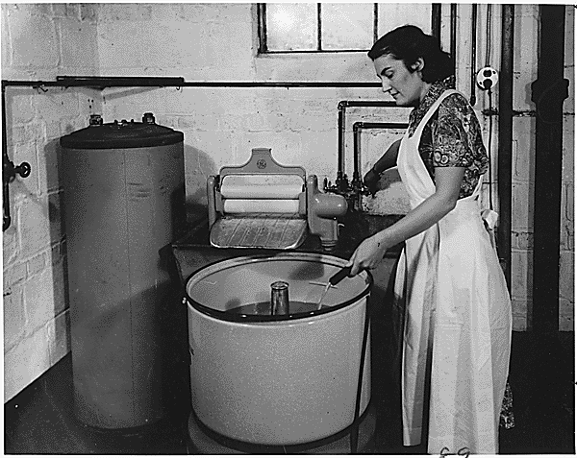

**Back in those days we didn’t have the many convenience appliances like we do today**. They hadn’t invented the automatic washer & dryer, so mom had a Dexter washer with twin tubs and a wringer which had a handle and you would put an article of clothes on the one side and start turning the handle and the clothes would go through between two round wooden cylinders (looked like big rolling pins) and fall into the next tub. Mom would put Tide & bleach in the washer which had an agitator that went back and forth when you pushed the lever. This did work with an electric motor. Mom would put bluing in the last tub. We had a “wash house” in back of our house, which was a shed. It had one little electric bulb in the middle, but it seemed really dark and creepy out there. It seems like it had a dirt floor and I remember lots of spiders, etc., so I didn’t like being there, but I was the oldest daughter and I was expected to help with everything a woman does. I felt picked on, as my brothers did practically nothing, but I learned a lot which made me a better mother and homemaker. After the clothes had been in the washer for a length of time, Mom or I would stop the agitator, take out the clothes one by one and take them through the wringer into the first rinse tub. We would swish them around in that tub and take them through the wringer into the second tub with the bluing. The bluing was to make the white clothes whiter. We would them take them through the wringer and they would drop into a basket. Mom made starch to starch Dad’s collars on his white shirts, etc. Then Mom & I would take the clothes outside to the clothes lines and hang them on the lines with clothes pins. In the winter, this was difficult as our fingers would get so cold hanging these wet clothes on the lines. They wouldn’t get completely dry, in the winter, unless there was a good breeze and so we would gather them up in the late afternoon, take them into the house and drape them over the chairs, or on anything we could find, for them to dry. We didn’t have permanent press clothes, they were all cotton and we used to iron practically everything. So, Mondays were wash days and Tuesdays were ironing days. On Monday afternoons, we would sprinkle the clothing that was to be ironed. Sometimes you had a bottle with a top which had holes in it, otherwise you just used a pan of water and used your hand to sprinkle water on the clothes. You would them roll them up and put them into the basket, and put a folded bath towel over the basket. If it was winter and the clothes did not get dry, you didn’t have to sprinkle them very much. We didn’t have steam irons, so that’s why we needed to sprinkle and roll them up to iron the next day, as they needed to be damp. I didn’t enjoy ironing. We didn’t iron sheets, towels, underwear or socks, but practically everything else. It took most of the day. I was surely glad when permanent press clothes came out. I don't mind pressing clothes sometimes, but I dislike ironing like we used to have to do then. Later on, Mom got a "Mangle Ironer". It was a machine with a roller. You could easily iron pillow cases, handkerchiefs, table cloths, etc., but it was a little tricky to do shirts, blouses and dresses, but we did what we could of them and then used the other iron to do the rest. We thought that was great when we got it. After I was married and living in Mesa, Arizona, we bought a "Mangle Ironer" also - until the permanent-press clothes came out. Of course, when I was old enough to go to school, then mom would do most of these jobs, except for the summers. However, it was usually my job to fold the clothes when I got home from school on Mondays. We didn’t have paper diapers in those days and since I was the 2nd of 6 children, there were lots of cloth diapers to wash and fold. I also remember washing the dirty diapers out in the toilet a lot and then putting them into a bucket with a lid to wait until Monday to wash. On Mondays, Mom usually cooked beans for supper as it was easy and could cook for several hours while we were doing the laundry.

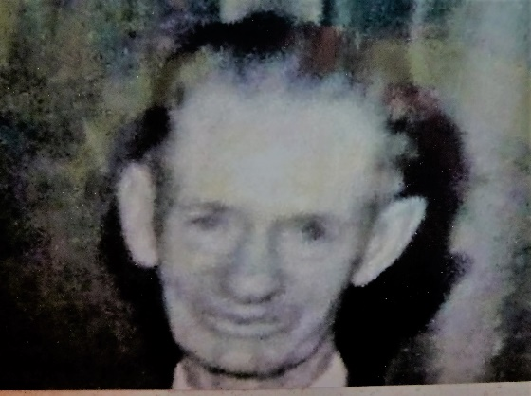

When I was a young girl, probably six or seven, an older man, a grandpa **- Mr. William Boren**, moved into our ward. He lived alone. I later found out he was divorced. He was active in the church and worked at Hill Air Force Base. I guess his wife must have turned his children against him as he seemed a little bitter towards his wife and children. He didn't have anyone to spend his money on and he enjoyed making little girls happy - so he'd buy presents, for several of us girls in the ward, especially on our birthdays and Christmas. He'd take us to the circus, Lagoon and other fun places. He'd buy us candy and other treats. When we were sick he'd come to visit us and bring us goodies and comic books to cheer us up. I seemed to be his favorite as he would always buy me the nicest and most expensive items. For example, one year for Christmas he gave me and my friends a bike. Theirs were smaller, cheaper bikes, but mine was a Swinn. It had lights, a horn and was a larger, nicer one. Another year he gave us watches. He gave them Cinderella watches, but he gave me a beautiful woman’s watch. He told me the reason he did this was because he knew I appreciated it more and that I would take better care of the things he gave me than the other girls would. When I was sick, he'd bring me comic books, pop and ice cream, (usually a quart) and sometimes cookies. I was always really excited, but this caused Hal to be jealous. I don't blame him. It would have been hard for him when I was always getting nice presents or treats or being taken to special places where children love to go and he wasn't invited or given gifts. Bryce was a lot younger so he didn't understand too much about it so I don't believe it affected him too much. I didn't always get to go because dad sometimes didn't approve and didn't know whether to trust him that much. Some people in the ward gossiped about him and said he was probably a "dirty old man". This hurt and upset him as he wasn't that way at all. He was a gentle, kind, good man. He just preferred little girls and enjoyed doing things for them and making them happy since his own family was a source of unhappiness. He was like a grandpa to us and we, at least I, grew to love him like one. I never remember him ever doing or saying anything out of line. Later, his health began to fail and he was retired and went to live with one of his daughters. He came to visit me after I was married, and I was thrilled to see him. Mom always felt he was a kind elderly man and appreciated the kindness he showed me. Mr. Boren gave me a **beautiful green parakeet.** We kept the cage door open and it would fly around the house & land on your shoulder or head. One day my friend, Patsy Morris, was at my house and we were making cookies. All of a sudden, Patsy started screaming and jumping up and down and waving her hands frantically. I looked over at her and my Parakeet had landed on Patsy’s head and scared her to pieces. I started laughing, but she didn’t think it was funny. When she started screaming and jumping up and down, it scared the bird and he flew back in his cage. Patsy hadn’t known that the parakeet could get out of its cage. He would fly around sometimes and land on the wall can opener and you could lean over and he would give you a kiss on the cheek - cute bird.

I had a friend, **Anna Mae Bodily**, who lived in Clinton. Her Mom had died and she had two older brothers and the father never remarried. Sometimes Mom would let me go to her house after Elementary School and play for an hour or so and then walk home. One day after I got there, she wanted to show me her puppies. They were such cute, tiny little things. They were weaned. I made such a fuss over them that she asked if I would like one. I certainly did so I called Mom and she said I could have one. I brought it home with me that day in my coat pocket. It was that little. I named her **“Skippy”.** I took good care of her and I loved her so much. All the family loved her. When she came I heat we tried to keep her inside as there were large dogs roaming around outside all the time. Well, one time she got out and a big dog mated her. She had a hard time delivering her puppy as it was large. It was a brown and one mutt, but we loved it too. We named it **“Brownie”.** We had Skippy spaded after that. . We had about three years, I think, when she was out one morning and up by the highway and we heard a noise and ran outside and a car hurried off. The car had swung out onto the gravel (off the road) to hit and kill our Skippy. Mom & Dad were so upset that someone would do that, and I was heartbroken as I loved my little dog. I don’t remember how long we had Brownie when we found out that he had been picked up and was in the pound. We called the pound and they said we could come get him, but when we got there, he wasn’t there. They said that he had escaped over the chain fence, but we think they had already put him to sleep, so just told us that. We were sad about that too. The reason why he was in the pound was because of some bad neighbors, who lived in Lyman’s back apartments (close to the park). The man taught his kids to steal people’s fruit off their trees and other things. They stole fruit from Grandpa, and he caught them and took them to their parent’s home and the dad got mad at them and said “I taught you not to get caught.” The man would walk past our house to get to the corner store and buy his beer and cigarettes, and if Brownie was outside, he would run towards him barking and growling as he didn’t like him. I think animals have an instinct when people are bad, because Brownie didn’t bark at other people passing by. Anyway, we’re sure that this man turned Brownie in.

Grandma Bushnell had a beautiful **yellow canary**. I loved listening to her canary sing. Sometimes it sang so loud that if she had other people there, they couldn’t hear each other talk, so she would put a cover over the cage and it would quiet down. Since I loved that canary, she gave it to me after Ken and I were married and living in our home in Ogden. Grandma had a feather mattress and sometimes, when Grandpa was away for the night, like when he took one of my brothers with him to Meadow when he was asked to sing, Grandma had me sleep with her. She was always nervous about being alone in her home, and I loved spending the night with her and sleeping in that soft feather mattress. One day I asked her if when she died, if she would will her mattress to me. She did, but Ken didn’t want it, so I didn’t get it. I wasn’t too happy with him.

**I started babysitting from the time I was 10 years old, and made $.25 an hour**, and then I did have money to be able to spend on myself and I liked that. I babysat some for people in Lyman’s back apartments. They were down at the end of their property, close by where the park is now. They were cheap apartments so all kinds of people lived there. I remember babysitting one time and after I got the children to sleep, I saw a hugh spider and it ran so fast across the floor. I was very afraid of it so I sat the rest of the night on the couch, with my feet up on the couch, watching for it to reappear, but hoping it wouldn’t, until the couple got home. Another time after the children were in bed, I saw a man outside, staring at me through the window. They didn’t have blinds on that front window. Thank goodness I had the door locked, but it still made me very nervous. I ran into the other room and was relieved when the people got home. I remember other times I would hear all kinds of strange noises and I could imagine someone walking around in the house and I knew the children were asleep. I was very nervous. I think it was just the sounds of the furnace.

I babysat until **I was 15 when I got a job as a carhop at an A & W Drive-in in Clearfield.**  I didn't like carhopping so the next summer I applied at the **Arctic Circle** in Roy and got the job. Delgarn Smith was the owner. He was really strict. He only had old fashioned cash registers at the two counters. We were to help all the customers as they walked up to the counter. We were to keep the orders in our heads, figure them up in our heads and get the orders out in the order they came in. It was hard, especially at first, but I liked the job. I liked the girls & guys I worked with. They were from Weber High so it was easy for me to get them to trade with me so I could go to the activities, games and dances at Davis, because Weber activities were usually on different nights. I could even get them to trade with me when I had dates as there were so many of them who wanted me to trade with them. It was also fun flirting with the cute guys who came there. I worked there until I was married.

**Selling tomatoes & cucumbers in front of our home**. Dad had leased some land from his brother, Uncle Verle, one summer and grew tomatoes, cucumbers and other vegetables and he had us kids put our card table out in front, under the shade of our tree, by the highway with a sign, scales, muffin tins with change, etc. It was kind of fun and we made pretty good money.

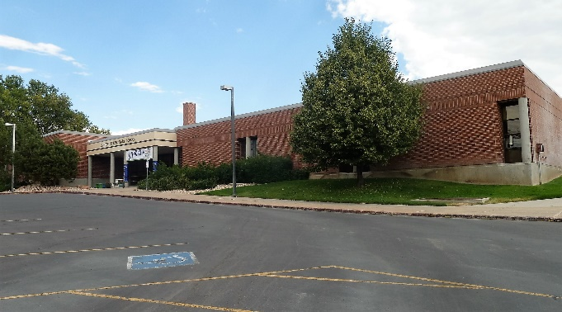**For my schooling, I went to Clinton Elementary, North Davis Jr. High, and graduated from Davis High in Kaysville, Utah in 1959. I also graduated from Seminary.**

We rode a school bus to Clinton Elementary, but it was only a mile from my house to the school so sometimes when I had to come home for dentist appointments or other reasons, Mom would call to excuse me and I would walk home. I enjoyed walking home as there was a ditch by the side of the road and in the middle of it was a cement division about six inches wide - so I liked to walk it and pretend I was a tightrope walker. There was one place about halfway home that made me nervous. It was an old deserted house with trees around it. It looked really scary and I had heard tales that a witch lives in it - so I would walk on the other side of the road just before I got to that place and I walked or ran really fast past it and was greatly relieved when I came to other houses and knew I could go to them for help if the witch started chasing me. (Oh boy, children's fantasies)

I liked Clinton Elementary and had many friends who I grew up with, and boyfriends too, which made it fun. I can remember (I think it was in the 5th grade) that I had two boyfriends who would write and pass notes to me saying "Do you like me more than Dan?" and Dan would say "Do you like me better than John?" I would write back saying I liked them both the same. We played softball, especially during my 6th grade and I usually played 2nd base. I also played "Jacks" a lot and got pretty good at it. Pat & I played it a lot at our homes and we played with a group of girls during recess in elementary school. I still like playing "Jacks and am still pretty good at it. I have taught it to my children. We also played "hop scotch" & "jump rope".

**We had ward shows on Monday nights**. They were paid for out of the monthly "budget" check every active family paid. We had a budget card which we showed to get into the movies which were held in the cultural hall. They had Walt Disney and other good family shows. Of course, in those days, most of the movies were good. The mutual youth (now called Young Men and Young Women) would bake goodies and make popcorn and have drinks to sell to earn money for their organizations. Usually, just the kids went to the shows and not the adults as it was too noisy and the adults didn't enjoy them. I remember Jimmy Petersen wanting to "take me" to the ward shows and asking me on the school bus if I would go with him and sit with him. Usually, I would sit with my girlfriends and sometimes my brothers & sister. Those movies were something we looked forward to each week.

Since I lived up by the highway and my other friends lived in subdivisions further west, I didn't get to play with them as much as I would have liked, and as much as they played with each other. Another reason was Mom had me helping with the housework, meals, laundry, tending children, etc., so I didn't have as much extra time to play. Saturdays were really busy cleaning the house and going grocery shopping - so when I was younger I didn't get to play much on Saturdays either. On Sundays, after the dinner dishes were over, Mom would let me go play with my friends. We were not allowed to play softball or go to the park, however, as it was Sunday. Many times, she asked me to take Bryce along (when I was about 8 - 12 years old) and Georgia from the time I was about 12 - 15) My friend, Patsy, just had one brother and he was older than her, so she didn’t always like me bringing Bryce with me. I remember one incident when I was riding Georgia behind me on my bike to go down to Patsy Morris's house. Georgia was about 2 or 3 years old. I put her on behind and took off. As I rounded a corner in the housing project where Patsy lived, Georgia's foot got caught in the spokes, she screamed and I quickly stopped the bike, but her poor little foot and leg were caught and were bleeding. A neighbor saw what had happened so he ran over to help me. Finally, we got her leg out and he took us home in his car where Georgia could be bandaged up.

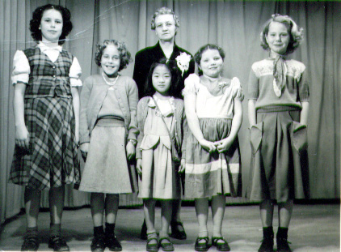 One day I was down to my friend, Margie Martin's house. We were twirling around on a homemade merry-go-round. All of a sudden, a board, that was propped up to hold up her mother's clothes lines, fell and hit me on the head. It didn't seem to hurt too bad so I didn't think too much about it until Margie noticed my head was bleeding. The board had a nail in it and it went into the top of my head. It began to bleed quite a bit and I got scared and started running for home. Margie ran into her house and told her mom who immediately jumped into her car and came and picked me up and took me home. She told me I shouldn't run when I was bleeding or it could make it worse. Mom put antiseptic on it and bandaged it, but felt it would be alright and not need stitches or tetanus shot as I had recently had one. It healed, but for several years whenever I parted my hair differently it would hurt.

**This picture shows my friends. (From left to right) Joann Hill, Bonnie Draper, Marian Nishamoto, Patsy Morris and Margie Martin. Grandma Bushnell was our teacher. That was special. I wasn’t in this picture because I was home sick.**

**Mom didn’t learn to drive until I was a teenager** so dad either drove us places or we rode the bus. The bus stop was across the street. I can remember standing at the bus stop with Mom and riding the bus to Ogden to go shopping. I remember, when I was a little girl, walking with Mom as we shopped and I had a hard time keeping up with her as she walked so fast. Now I have to slow down, when I walk with her, as she can’t walk very fast now that she is older. But, I still enjoy walking with her and being with her. Mom would spoil me sometimes, especially when I was a teenager and we went to Samuel’s sale. She would be excited when I would try on clothes that looked cute on me, and say “let’s get it for you”. I knew that was a sacrifice as my parents didn’t have much money. Throughout my life, she has always liked to give me clothes and other things as well. In fact, I rarely left Mom’s house without something in my arms that she had given me. Sometimes it was clothes, sometimes bread or cookies, fruit or vegetables or maybe some stew she had made. Many times it was something for Ken or the children too. Sometimes it was a “treasure” she got at a garage sale or a box of cereal she got at the “Canned Foods” store. Now that she is gone (today’s date 4/28/2000) I don’t want to go to the “Canned Foods” store because I took her to that store often, and it brings back all those memories, and makes me sad as I miss her.

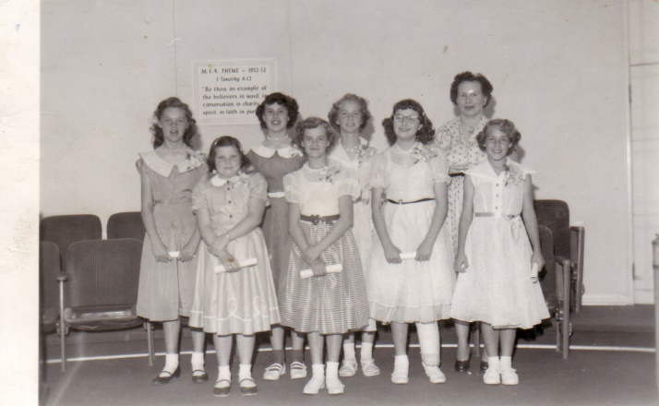This is a picture of me and my friends as we graduated from Primary. Pat Kleitches, my best friend, is the tall girl on the left, Patsy Morris is the short girl next to Pat, Joann Hill is on back row, then Margie Martin, then our teacher, Phyllis Martin. I am on the front next to Patsy Morris. I don’t remember the girl next to me as she didn’t live in Sunset very long. Bonnie Draper is next to her.

In the summer before the third grade a new friend, **Patricia Kleitches (Pat)** moved in three houses away from me. Actually, they moved into a duplex apartment that one of our neighbors owned behind her home. Pat was an only child and we became fast friends. She was tall and I was a lot shorter than her, but we really enjoyed each other. She wasn't a member of the church, but her parents let her attend church with me. They were not very good parents. Her mother had Pat do most of the housework, and always the dishes. If Pat left any water spots on a glass or any food on a dish, etc., her mother would make her wash and dry all the dishes over again. Her mother would run her fingers over the top of the stove and if there was any grease on it, she would make her scrub it all over again. Many times, we had something planned so Pat would hurry to get them done, and her mother would make her do them again, thus making us late or canceling our plans. I was nervous when I went to her house because her mother was so nervous that I might break something or bring dirt into the house, etc. Her dad didn't like our church and was always confronting me with things like: "How come your church tells your people you can't smoke or drink? When I would explain, he'd say "well I work with some of your people and they sure smoke and drink, step out on their wives, swear, take the Lord's name in vain, etc., etc., etc. He was a character. I wondered, over the years, if maybe Pat's parents had had to get married and so they blamed Pat, as they sure were not very good to her. For Christmas they would buy each other lots of nice clothes, shoes, appliances for Hazel, (her Mom) guns, etc., for Robert/Bob (her dad), but they would hardly buy Pat anything at all, and what they did buy her was usually from the Deseret Industries or other thrift stores. They wouldn't give her the money to join sports or clubs at school or do extracurricular things. One thing they did do for her though was to let her take accordion lessons with me and they bought her a nice accordion. Two of our other friends, Margie & Joanne took these lessons with us too. Pat became the most proficient on it.

Pat's parents did invite me to go fishing a couple of times with them, and Pat and I had fun. Her parents weren't all bad, but I sure appreciated my parents when I would be around hers. Her mother yelled at her a lot. Her Mom was quite sickly (probably why she was so temperamental) so was in the hospital quite a bit. One day when we were teenagers, Pat said "I hate my dad". I said "Oh, I know you get upset with him and I don't blame you, but you can't hate him". She said "Mae, if your dad did to you what my dad does to me, you would hate your dad too." She then proceeded to tell me how he abused her sexually whenever her mother was in the hospital or out of town, and would threaten her not to tell her mother or anyone. Boy that blew me away. I had never heard much of sexual abuse at that time - so I was shocked.

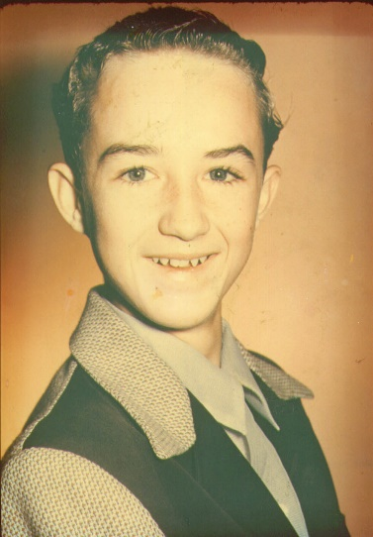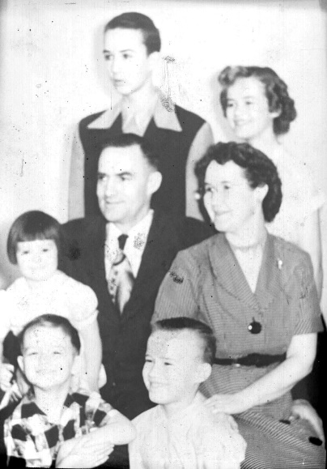**When I was growing up, Mom needed my help with cleaning house, laundry, meals, tending the younger children, etc**. I didn't think it was fair that my brothers didn't have to help. Dad had grown up on a farm and thought boys should do outside work and girls should help their mothers and do the inside work. The problem with that was - I only had one sister and she was almost 11 years younger than I and I had four brothers. They only had the lawns to mow in the summer and the chickens to feed. Sometimes they had to help weed the garden, but I did too. Oh, they had to take out the garbage too (Big deal) Sometimes **Hal would sit around teasing me while I was doing dishes, etc. He would say "work harder slave". He'd laugh and say, "I can go play with friends, or do anything I want, but you have to stay here and work, work, work - work harder slave."**  Sometimes I'd get so upset and tell him to get the heck out of here - to go to his friends then. One time I got so angry that I threw a glass at him. (Sure glad he ducked) I got in trouble for that. I am thankful that even though I complained and thought it was unfair then, I am thankful I was taught the value of work. My mom & dad used a “switch” which they kept on the top of the top cupboard by the door. Whenever they asked us to do something and we didn’t do it or complained or were fighting with each other, they would get the “switch” (small, long tree branch) down and threaten to use it on us. I don’t remember them using it on me, but I think they did on Hal a time or two. I remember Mom counting to five as a means of getting us to do things also.

**Our family went on a vacation** a few times while I was growing up. We usually went to Southern Utah - Bryce's Canyon, Zion’s, or to visit relatives who lived in southern Utah. It was great. I enjoyed these trips very much and loved doing things and going places with the family. I had 2 cousins who were close to my age – Joyce was 6 months younger and lived in Fillmore and Koye was 6 months older and lived in Henryville. Koye would get to come up sometimes in the summer and stay with Grandpa and Grandma and we had lots of fun together and became good friends. I was also able to stay at Joyce’s home for a week some summers and we had lots of fun together and became good friends. Whenever we had a family reunion, us three cousins loved it so we could be together again.

I remember stopping at **Brown's Ice Cream Store** in Ogden where Dad would buy us an ice cream cone for a treat when we were coming back from visiting our grandparents in Richville, Morgan County, or when we were in Ogden for other reasons. I usually choose Green Pineapple. That was my favorite. After the soft ice cream came in and we had drive-ins, we sometimes stopped at the Arctic Circle in Roy for an ice cream cone.

We went on picnics up Weber canyon sometimes. Those were always great times. Sometimes, in the summer, Mom would have us kids set up a card table out on the front lawn and we would have a picnic supper out there. When I was younger I liked it, but when I was a teenager, I was embarrassed that cars passing by would see us and think that was strange, and maybe some of my friends would be in those cars. We didn’t have lawn in back of the house, just buildings, a garden, fruit trees and before Sunset City bought some of dad’s property to make the Sunset Park, we had chickens and a cow back there.

**Sunday church was different back then**. First, the men and Aaronic Priesthood young men would go to Priesthood Meeting at 8:00 am. Sunday School started at 10 a.m. and was for everyone. We had opening exercises first which consisted of opening song, prayer, 2 two and a half minute talks by the youth, and music time when the chorister would teach us a new hymn or go over some of the other hymns with us. We would then separate for class. Sacrament Meeting was at 5 or 7 PM. In those days the parents sat with their young children, but the older children and teenagers sat with their friends. They changed this a few years later and asked parents to have all their children sit with them. I’m sure this is because they could see the older children and teenagers were not paying attention to the speakers, they were whispering to each other and goofing off. Many times, when my brothers and sister were young, Mom would have either Hal or I or both of us stay home and tend the younger children. Later on, parents were asked not to do this either as they told the parents that even if you think you’re not getting much out of the meetings because your babies & younger children are acting up, they need to be there with you to learn how to be reverent. Mom didn’t usually go to Sunday School, instead she would stay home and cook our wonderful Sunday dinner for us, so it would be ready shortly after we got home from Sunday School. Mom would make roast beef, potatoes, brown gravy, vegetable (peas, beans or corn), Jell-O salad with fruit in, and a delicious cake. Sometimes it had 7-minute frosting on, other times Carmel, chocolate or white.